CHAPTER 3: TECHNOLOGY TOUCH, MARKETING MIX AND EXECUTION
1. LawShield Technology Touch
LawShield brings legal research, AI document assistance and legal work management into one platform. Its web workspace supports individual and organizational workflows, while the mobile application gives users access to Lexi, legal lookup and documents on iOS and Android. The following sections explain the main technologies, product development and mobile release process behind these services.
1.1. System Architecture Diagram
LawShield connects its web and mobile applications to a shared backend. This design allows accounts, legal sources and AI services to support both platforms, while the web interface provides broader tools for organizational work. Figure 7 presents the main application layers and the services used to manage legal information and documents.
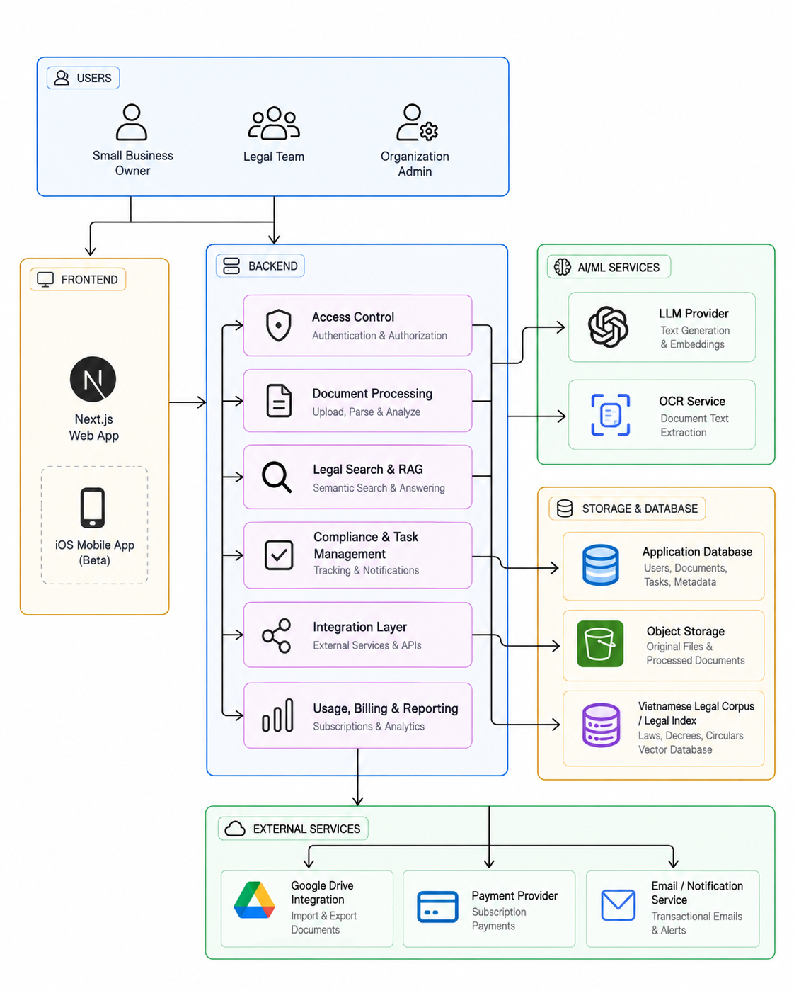
Figure 7. LawShield system architecture
(Source: Authors)
1.1.1. Client Applications
Web application with Next.js and React: The web interface provides Lexi chat, legal research, contract tools and the organizational workspace. TypeScript supports consistent development across these functions, while Tailwind CSS and shared interface components help maintain a coherent visual design.
Mobile application with Flutter: Flutter and Dart provide a shared codebase for iOS and Android. The mobile experience concentrates on legal questions, source lookup, documents and account services, with platform integrations for Google or Apple sign-in and iOS subscriptions.
1.1.2. Core Application
FastAPI backend: FastAPI organizes the application into modules for authentication, legal research, documents, organizations, credits and lawyer services. These modules share a common application, allowing related workflows to exchange information and apply consistent access rules.
Lexi AI and legal retrieval: OpenAI services support conversation and document assistance. Retrieval Augmented Generation combines the AI response with relevant Vietnamese legal sources. Users can inspect cited articles and supporting material when assessing an answer.
Redis: Redis supports caching, request limits and notification events. These functions reduce repeated processing and help the application coordinate updates between services and connected users.
Background processing: Application background tasks handle recurring work such as cleanup and credit reconciliation. This keeps routine maintenance separate from the main user interaction.
1.1.3. Authentication and User Engagement
OAuth 2.0 and OpenID Connect: Google sign-in and Sign in with Apple let users authenticate through supported identity providers. Email and password access is also available, giving users several ways to enter the platform.
JSON Web Tokens: JWT access and refresh tokens maintain authenticated sessions after sign-in. The web application uses protected cookies, while the mobile application uses secure device storage for session information.
Streaming and notifications: Server-Sent Events deliver Lexi responses progressively and support application updates. Email integration provides an additional channel for account and service communication.
1.1.4. Data and Document Storage
PostgreSQL and pgvector: PostgreSQL stores accounts, application records and the legal corpus. The pgvector extension adds semantic search alongside keyword search, helping Lexi locate supporting legal passages even when a user phrases a question differently from the source.
S3 compatible object storage: Vietnix object storage supports uploaded and generated documents. Persistent storage preserves files and application data across deployments.
OnlyOffice: OnlyOffice enables document editing in the browser. Together with document versions, it supports a workflow in which users can review AI suggestions, continue editing and save a revised document.
1.1.5. Payments and Subscription Management
PayOS: The web application integrates PayOS for supported booking payments. Payment status is connected to the relevant service workflow.
Apple StoreKit: The iOS application uses StoreKit for Basic, Pro and ProMax subscriptions, including purchase restoration. The backend verifies purchase records before applying the corresponding subscription benefits.
Credit management: A shared credit system records AI consumption and settles usage after an operation. This supports consistent usage accounting across the application.
1.1.6. DevOps and Automation
Docker Compose: Containers package the application and its supporting services into a repeatable deployment environment. Persistent volumes retain the data required by stateful services.
GitHub Actions: Automated workflows run code checks and prepare release images. Production deployment is initiated separately so the team can control when a new web release becomes available.
Caddy: Caddy provides HTTPS and routes incoming requests to the appropriate application service. The deployment process uses two application environments to prepare a release before switching traffic.
1.1.7. Security
Identity and access control: Argon2 password hashing, authenticated sessions and backend permission checks protect account access. Organization roles and membership rules govern access to shared work.
Transport and data access: HTTPS protects communication with the application. Document access checks and mobile AI sharing consent support controlled use of user content during legal assistance.
1.1.8. Monitoring and Usage Analysis
Infrastructure monitoring: Beszel and application health checks support observation of the running services. These tools help the team identify resource issues and investigate service interruptions.
AI usage records: Model usage logs and the credit ledger provide information about completed AI operations and their consumption. They support technical monitoring and the review of resource use.
1.2. CI/CD Pipeline Diagram
LawShield uses GitHub Actions to support code verification and web delivery. Changes pass through repository review and automated checks, while a separate release workflow builds Docker images and prepares the production deployment. The team can then verify the new application environment before Caddy switches incoming traffic.
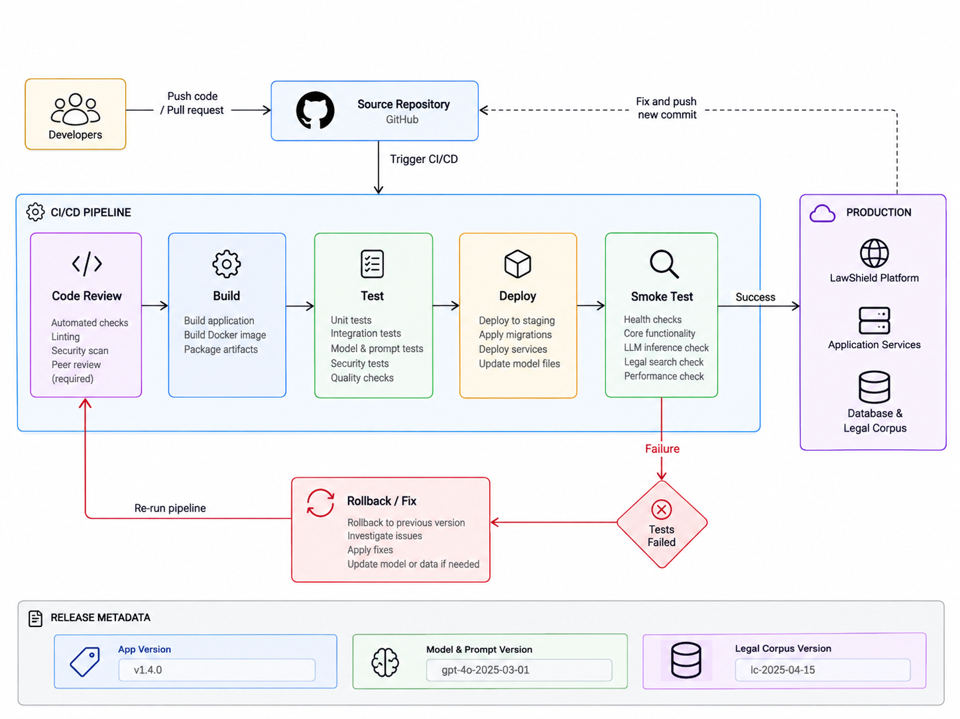
Figure 8. Web integration and deployment workflow
(Source: Authors)
The deployment process retains application data and prepares the idle environment before making it active. Health checks and a review of core functions support the release decision. Keeping the previous application image available also supports recovery if a release introduces a problem. Mobile distribution follows the additional Google Play and Apple review processes described in Section 1.7.
1.3. UI/UX Documentation
The interface is organized around the task a user wants to complete: ask a legal question, inspect a source, work on a document or manage legal work. Blue and white visual elements, shared navigation and recurring interface patterns connect the web and mobile experiences. The web workspace presents more organizational functions, while mobile navigation emphasizes frequent individual tasks.
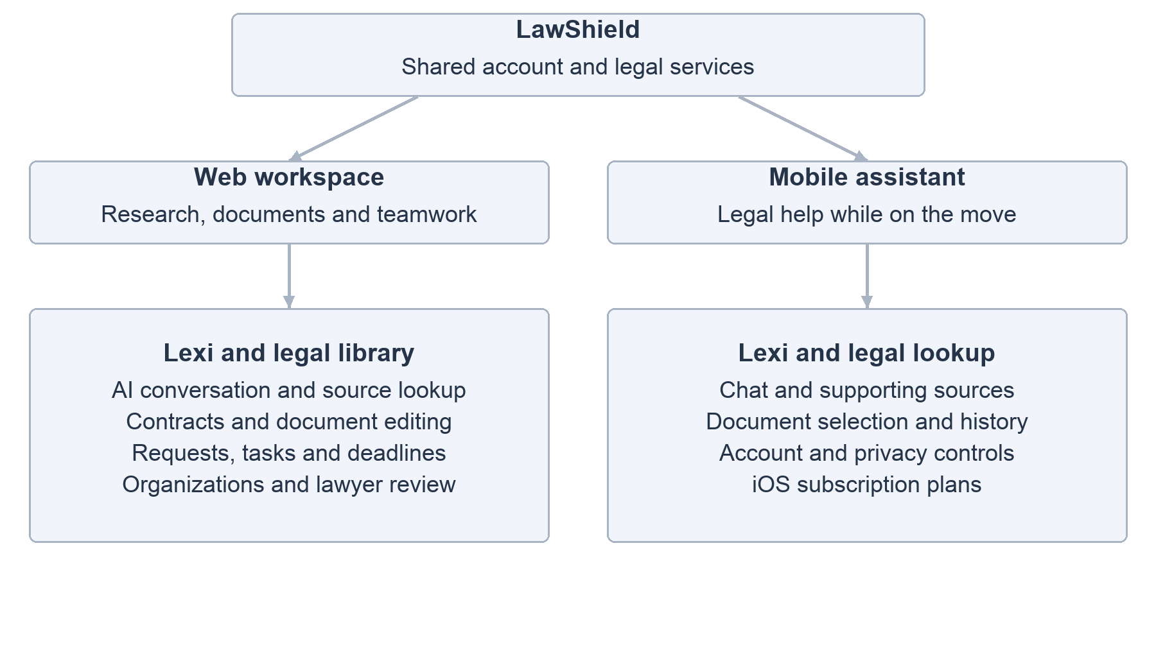
Figure 9. Main web and mobile navigation areas
(Source: Authors)
A typical Lexi journey begins with a question or a selected document. The user reads the response, opens relevant legal sources and decides whether to continue the conversation or revise a document. Web users can also move into task management or professional review when further action is needed. This sequence keeps source inspection and user review close to the AI result.
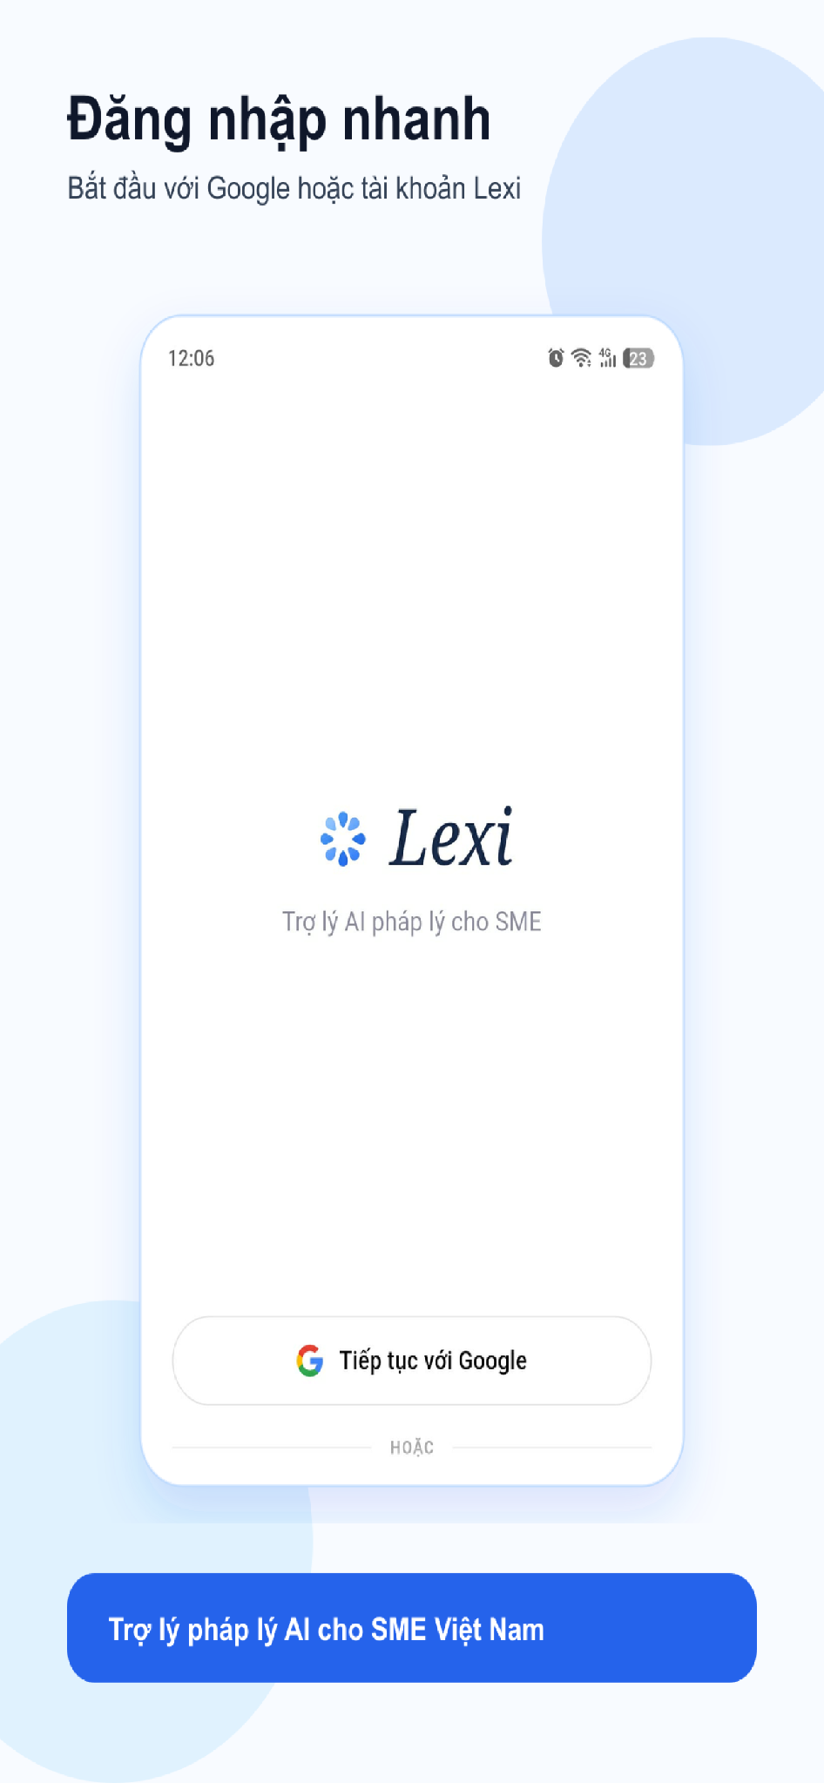 | 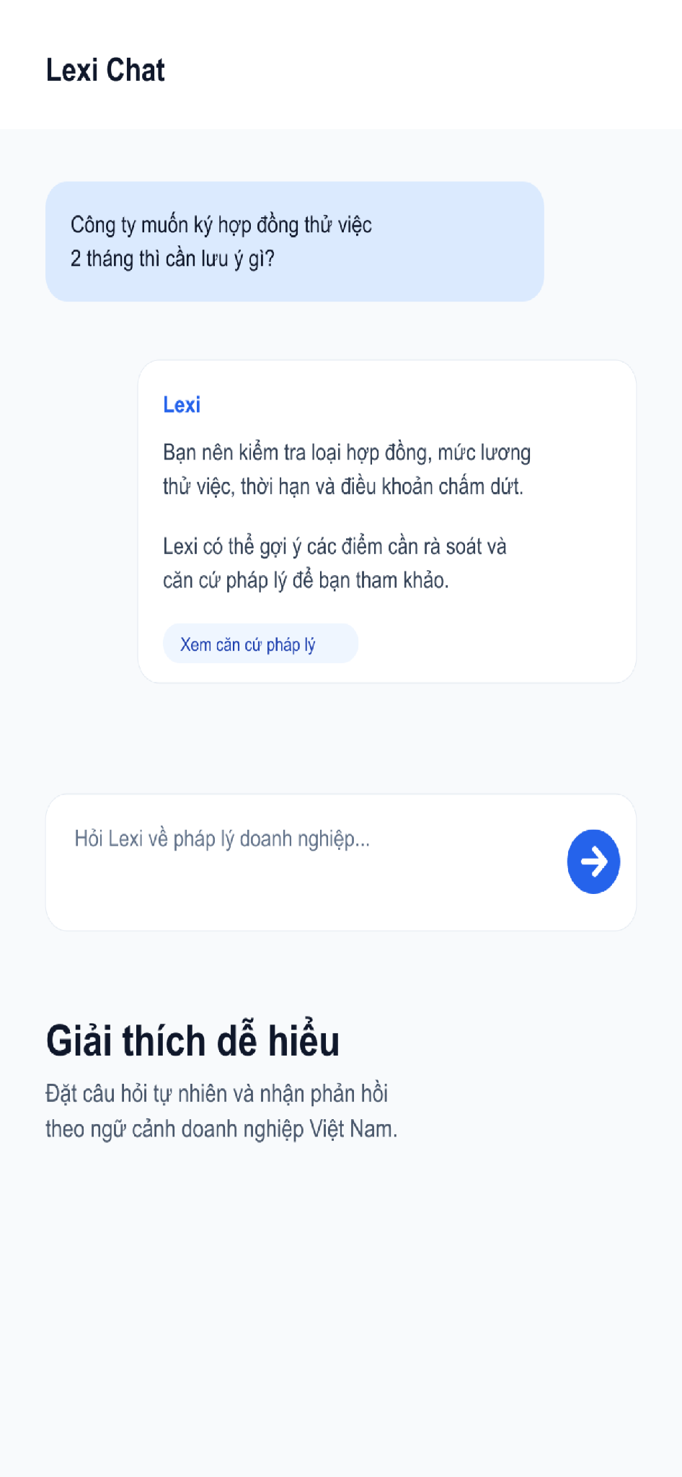 | 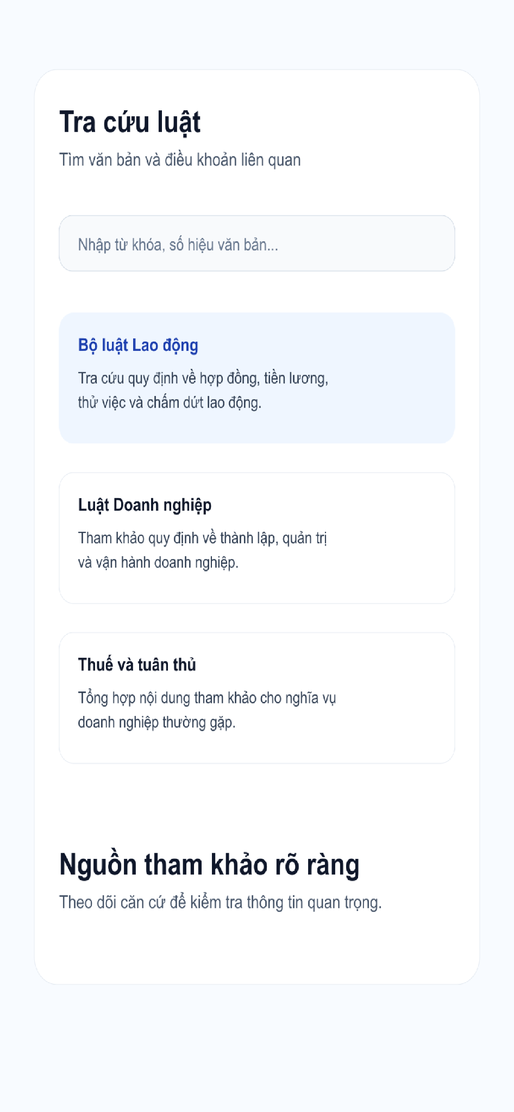
Figure 10. Mobile interface illustrations used in release materials
(Source: LawShield mobile project release assets)
1.4. Developing Phase
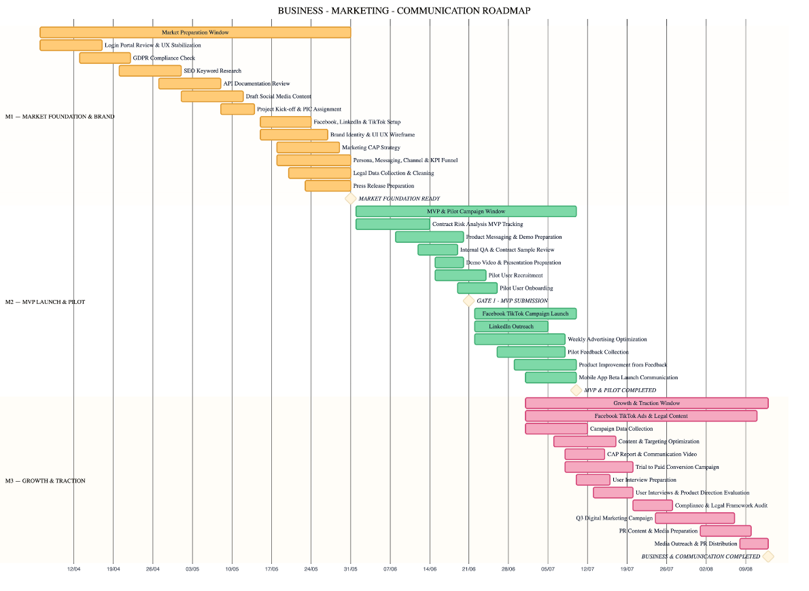
1.4.1. Ideation and Preparation
The project began with identifying difficulties in accessing Vietnamese legal information and turning legal findings into practical work. The preparation phase defined the main users and the initial scope: legal questions, source lookup and document assistance. These activities shaped Lexi as the starting point for the product, with organizational tools added around the same legal workflow.
1.4.2. Web Application Development
Web development established the shared backend, account system and legal corpus. The product then expanded from legal search and AI conversation to contract editing, document versions and the legal workspace. Organizations, requests, tasks and lawyer review connected individual research to work that requires coordination and follow-up.
1.4.3. Mobile Application Development
The mobile application reused the existing LawShield services through a Flutter client. Development focused on chat, legal lookup, document access and conversation history. Release preparation added the platform-specific account and subscription functions needed for distribution, including Apple sign-in, AI sharing consent, account deletion and iOS purchase restoration.
The overall development period combines web development from March to September 2026 with mobile work from August into October. Store preparation and review overlapped with application improvements, so the mobile release phase included both functional refinement and the completion of distribution requirements.
1.5. Key Features
LawShield groups its main functions around legal research, document work and collaboration. The web and mobile clients share the legal assistant and core services, while the web workspace provides the broader organizational workflow.
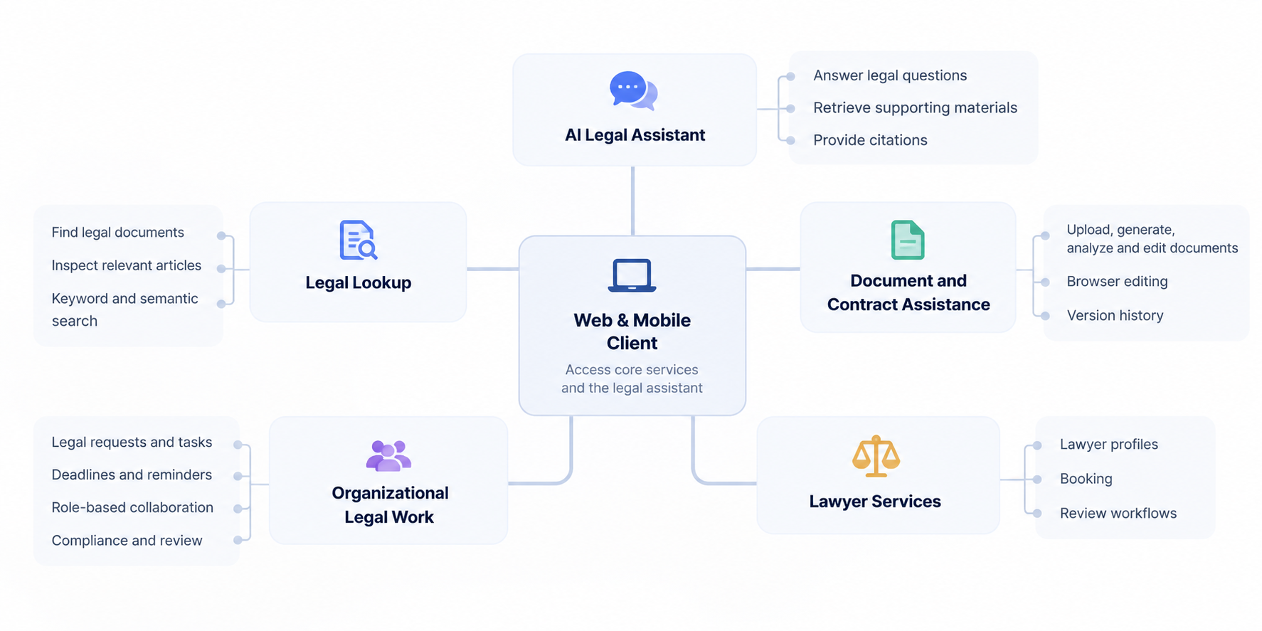
Figure 11. LawShield feature overview
(Source: Authors)
AI legal assistant: Lexi answers legal questions, retrieves supporting materials and provides citations for further inspection. Conversations and selected documents give users context for follow-up questions.
Legal lookup: Users can find legal documents and inspect relevant articles. Combining keyword and semantic retrieval supports both direct searches and questions expressed in everyday language.
Document and contract assistance: Users can upload, generate, analyze and edit documents. Browser editing and version history support review before a result is adopted or shared.
Organizational legal work: The web workspace supports legal requests, tasks, deadlines and role-based collaboration. Compliance and review functions help connect findings to work that needs a responsible person and follow-up.
Lawyer services: Lawyer profiles, booking and review workflows provide a path to professional support when a task needs further assessment.
1.6. Development Milestones
The project progressed from defining the legal assistance workflow to delivering a shared web and mobile platform. Figure 12 summarizes the development periods and the available public release checkpoints.
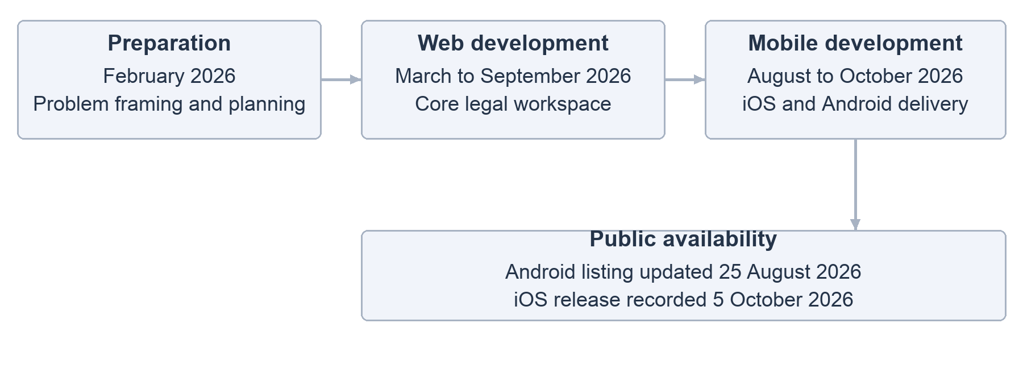
Figure 12. Development periods and public release checkpoints
(Source: Authors)
February 2026 | Preparation: The team framed the problem, identified the initial product scope and planned the legal assistant workflow.
March to September 2026 | Web development: The web platform developed its legal research, document and organizational functions on a shared backend.
August to October 2026 | Mobile and release preparation: Flutter development brought Lexi and legal lookup to mobile. Subsequent work addressed account controls, privacy and subscription requirements for app store review.
Public release checkpoints: The Google Play listing displays an update date of 25 August 2026. Apple records the iOS public release on 5 October 2026. The Google Play update date identifies the listed update rather than establishing the first Android publication date.
1.7. Mobile Application Appraisal by Google and Apple
Mobile delivery requires more than a successful application build. Both stores require a signed package, listing information, privacy declarations and a review process. LawShield maintains release guidance for Android and iOS to organize these steps and respond to platform feedback.
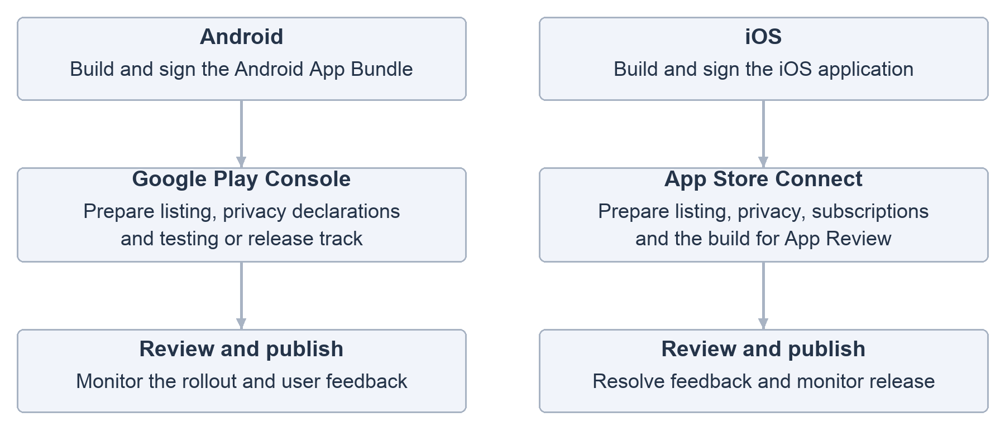
Figure 13. Android and iOS store delivery process
(Source: Authors)
1.7.1. Google Play Release Process
The Android workflow prepares a signed Android App Bundle, completes the Play Console listing and data declarations, and selects the appropriate testing or production track. Review is followed by rollout monitoring and checks of sign-in, legal lookup and chat. The project release guide also describes staged rollout as a way to observe problems before wider distribution.
LawShield has a public Google Play listing. The listing provides the Android availability checkpoint, while the release guide provides the operating procedure for future submissions. Each release should retain its build record, review outcome and rollout notes so the team can compare the submitted build with what users receive.
1.7.2. Apple App Store Review Process
The iOS workflow covers signing, App Store Connect setup, build upload and App Review, with TestFlight available for pre-release validation. Subscription products, privacy information and the application build must be prepared together because the purchase experience forms part of the review.
The project iOS report describes review issues involving external payment access, subscription submission and missing Privacy or Terms links. The subsequent work addressed the iOS purchase flow, subscription information and restoration. Apple public metadata records LawShield as released on 5 October 2026.
1.7.3. Lessons from Mobile Delivery
Store requirements influenced account, privacy and payment design during development. Completing these elements early makes the submitted product easier to review and reduces repeated changes near release. A practical checklist should cover signing, reviewer access, privacy disclosures, account deletion and the full purchase and restoration journey, followed by checks after publication.
1.8. Performance Metrics
LawShield monitors application operation through service health checks, infrastructure monitoring and AI usage records. Public availability on both stores confirms distribution, while product performance requires measurements over a defined period. The main technical measures for continued evaluation are outlined below.
Application reliability: Track successful requests, failed operations and service interruptions. Separate normal account or workspace requests from longer AI and document operations when reviewing response time.
AI and retrieval quality: Review whether retrieved legal sources are relevant and whether an answer is supported by its citations. Legal currentness and the treatment of uncertain questions should be assessed alongside response speed.
Document processing: Measure upload and extraction success, completion time and the quality of document results. Tables and scanned documents need particular attention because extraction quality affects later analysis.
Mobile experience: Monitor crashes, sign-in completion and the success of core user journeys. On iOS, purchase completion and restoration should be checked as part of subscription reliability.
Resource consumption: Use infrastructure observations and AI usage records to understand resource demand per operation. These measurements guide optimization as the number and complexity of user requests increase.
A consistent measurement period and repeatable test cases will make future releases comparable. Priorities are reliable access, useful legal evidence and successful completion of the user journey.
1.9. Roadmap for Future Improvements
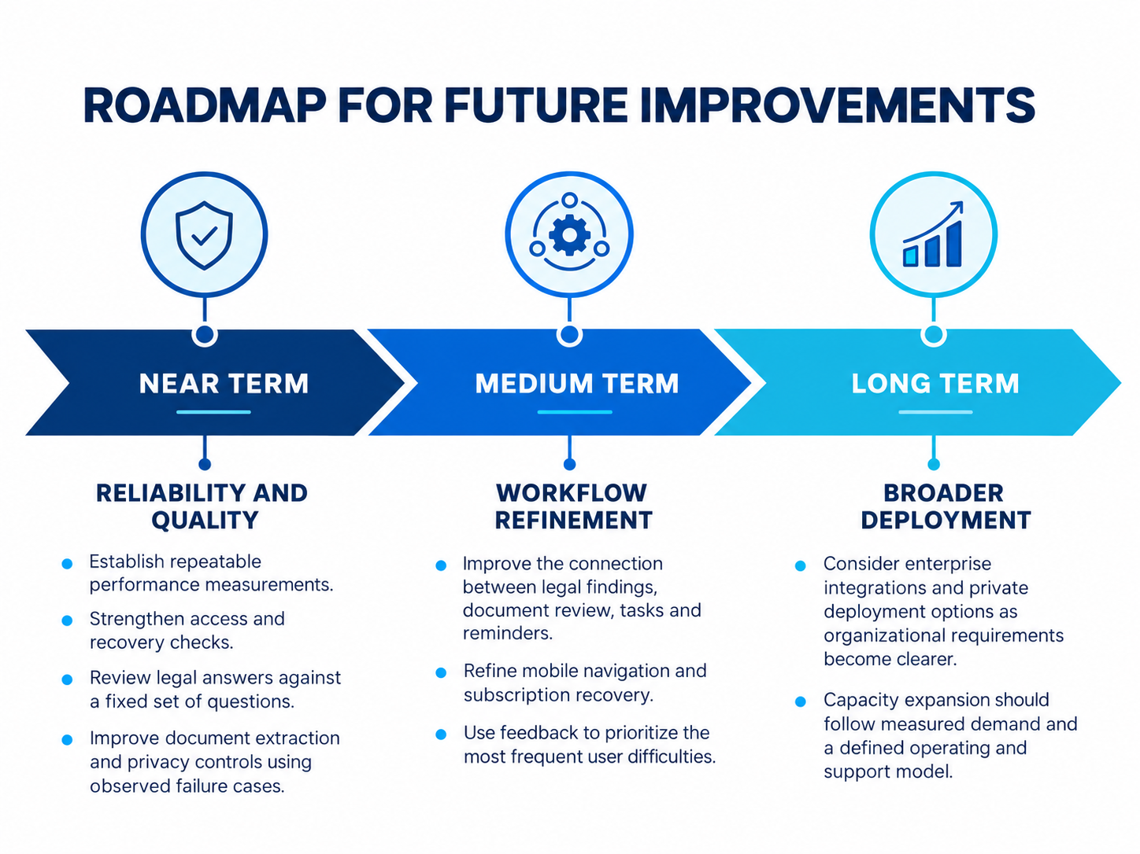
Near term | Reliability and quality: Establish repeatable performance measurements, strengthen access and recovery checks, and review legal answers against a fixed set of questions. Improve document extraction and privacy controls using observed failure cases.
Medium term | Workflow refinement: Improve the connection between legal findings, document review, tasks and reminders. Refine mobile navigation and subscription recovery, and use feedback to prioritize the most frequent user difficulties.
Long term | Broader deployment: Consider enterprise integrations and private deployment options as organizational requirements become clearer. Capacity expansion should follow measured demand and a defined operating and support model.
Technical and release sources
LawShield web and backend repository
LawShield mobile repository
Google Play launch timeline
LawShield iOS release process
LawShield on Google Play
LawShield on the Apple App Store

